Halogen Precipitates
Precipitates are insoluble solids that sometimes form when
solutions are mixed.
5 Add 3 drops of lead nitrate to each of the samples as
shown in below. Record your observations.

spotting tray
or white tile
Results
Construct a table to display your observations.
Discussion

1 The solid formed was a precipitate. Describe what a
precipitate is.
2 The precipitates formed were , lead chloride, lead bromide and lead iodide. Compare the precipitates formed by listing their similarities and differences.

3 Describe the changes in the colour of the precipitates as
you moved down group 17 from chlorine to iodine.
4 Predict what would happen if you tested potassium fluoride in the same way.
Purpose

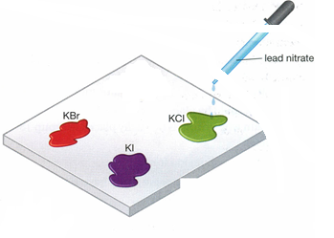
To compare the precipitates formed when lead combines
with different halogens.
Materials
disposable gloves
white tile or spotting
tray (tray with small
indents)
dropping bottles of
saturated solutions
of lead nitrate,
potassium iodide
(KI), potassium
chloride (KCl), and
potassium bromide
(KBr)
marker pen
SAFETY
Lead is toxic. Do not
get any of its compounds
on you.
Wear disposable gloves and
safety glasses at all times.
Wash your hands well after
the activity.
Procedure
1 Put your disposable gloves and safety glasses on.

2 Place 3 drops of potassium iodide solution in one
indent of the spotting tray or on one corner of the
white tile.
3 Use the marker pen to label this sample with KI

4 In the each of the other indents or corners, place 3 drops
of potassium chloride and potassium bromide solutions. Label them KCI, KBr respectively.


